**1st.(Johnny)** Good afternoon. We are the group 5 and Our presentation will cover Philippine cartoons and grievances against wood and we will also cover some works or luna and amorsolo.

The 1st document is about Philippines Cartoons: Political Caricatures of the American era. The authors of this document are (read the slide).

Alfred Mccoy and Alfredo Roces compiled political cartoons published in newspapers and periodicals in the aforementioned time period. Most of Articles were published by The Indepent and Lipag Kalabaw and drawn by artist Fernando Amorsolo and Jorge Pineda

This document is divided into 7 sections composes of Articles. (read slide 4)

This are some of the selected cartoons or caricatures that were used against the American and the context of each one. The 1st article is the

**The corruption of a City**

AT FIRST CONTACT, Manilenos found the sudden American presence disruptive. It was the small things that often outraged ordinary Filipinos. With the arrogance of the conqueror, for example, American soldiers and sailors strutted about Manila's streets. From these slices of street life, the cartoonists could often make a sharp political point masquerading as innocent social commentary.

* Memories of a Visit

- The American sailors poured into manila off the U.S. Asiatic Fleet in November 1908, Crowding

into bars and brothels, a stream of shoeshine boy and calesa drivers following in their wake.

The Cartoonist here shows one shoeshine boy asking another: " what did we profit from the

P100,000 which the sailors visiting here are supposed to have spent? The other answers:

"Nothing, they left us the dirt from their shoes."

* Municipal Hygiene

- Determined to transform manila from tawdry Asiatic port into a model metropolis, the american

imposed strict sanitation regulations that angered the Manilenos

This cartoonist shows public reaction to the noxious odors from the excrement pail wagon

that were serviced outside toilets, the chemical spraying of streets and houses to prevent

disease was even more distasteful.

**_____________________________________________________________________________________**

**2nd. (Patrick) The Distant Province**

THE PROVINCES BEGAN at Manila's door-step, but for the city's press they were a world apart. The editors, writers and cartoonists all lived in Manila and made the press a chronicle of urban life. The cartoons are then a remarkably detailed and precise record of the city's changing face-fashion, morality, politics, transport, and commerce.

* Convenient Blindness

- is the translation of a satirical comment on the provincial's preoccupation with gambling.

Outside the municipal hall provincial officials, their eyes glazed over with visions of Conant

pesos, gamble at cards.

The caption says that in a province near Manila gambling is so widespread that everyone -

the municipal president, provincial board and governor - do nothing but gamble.

* Regattas in Batangas

- celebrates the sweeping victory of the nationalist candidates in the 1907 Assembly elections

in Batangas Province. The winning candidates are (left to right) Eusebio Orense (Nacionalista,

Second District), Gregorio Katigbak (Nacionalista, Third District), and

Felipe Agoncillo (Independent, First District)

**_____________________________________________________________________________________**

**3rd. (Young) The Colonial Condition**

FOR SOPHISTICATED FILIPINO nationalists, colonialism was not a simple matter of who occupied the executive offices in Malacañang Palace. They saw colonialism as a pervasive condition that had penetrated the whole of their social fabric - influencing their culture, politics, economy, and class relations. These nationalists, radical and conservative, felt that anti-colonialism had to move beyond mere agitation for independence and seek the revitalization of Filipino society, breaking this subtle system of colonial social controls would require reforms of religion, language and social relations.

* The Doctor is Busy

- The Doctor Is Busy and so refuses to see a dying patient.

In the midst of tying the talons on his fighting cock, the doctor is approached by a

peasant who pleads: "My wife is dying, señor, save her, señor! To this plea the fat doctor,

in hat with religious scapulary about his neck, replies:

"Be quiet. You are bothering me. Don't you see that I am busy."

The cartoon satirizes the haughty, unsympathetic manner of Filipino doctors who,

if this is any sample, felt that their medical degrees were license to command respect,

not to render service.

* A Mass is better

- mocks both the superstition of the Filipinos and the influence of the Spanish friars,

particularly among devout women. Evidently frightened by one of the recurring

cholera outbreaks of the period.

**_____________________________________________________________________________________**

**4th. (Sean) Uncle Sam and Little Juan**

SHOWN AS A SATANIC FIGURE with grotesque nose and

broken teeth, Uncle Sam cackles: " 'Divide and rule, said Machiavelli,

and since they are divided I shall naturally defeat them."

Taking a non-partisan nationalist position, the Lipag Kalabaw cartoon of September 1907,

just prior to the inauguration of the First Philippine Assembly, shows the parties hopelessly

divided into three main groups.

Uncle Sam - Americans

Juan - Filipino

* Inmediatistas, Unionistas and Urgentistas

- The group to the left near Uncle Sam is the Inmediatistas faction. This group was led by Dr. Justo Lukban (shown hands in pocket to the right of Uncle Sam’s Beard), Manuel Sityar (hands folded to Lukban’s right), Guerrero (hands behind back to Sityar's right). Renowned as the editor of the nationalist newspaper El Renacimienio. Guerrero won easily in the Manila South district. His ally Dr. Justo Lukban finished second in Manila North, but filed a successful protest against the winning Nacionalista candidate, Dr. Dominador Gomez. Not shown are their winning provincial candidates, Manuel Quezon of Tayabas and Sergio Osmeña of Cebu.

The center group represents the Urgentista faction led by Dr. Dominador Gomez (in hat with fan), Felipe Agoncillo (to his left), and Rafael Del Pan (to his right, second row). After being unscated by Lukban's protest, Dr. Gomez, a popular labor leader, won the Manila North seat in a special election.

The group at right is the Partido Union Progresista, the former Federalistas. Shown with beard, moustache and mourning band is Dr. T.H. Pardo de Tavera, a member of the Philippine Commission.

* The Parties Take Turns

- shows Uncle Sam doling out the meager patronage gruel left to the Filipinos,

first to the Progresista (Federalista) Party members who have until now monopolized

his largesse. With their victory in the July 1907 elections, the Nacionalistas are now

waiting their turn for Uncle Sam's patronage gruel.

**_____________________________________________________________________________________**

**5th. (Hover)The Aliens in our Midst**

During the first decades of U.S. rule, the Filipino press launched angry attacks on the Spanish friars.

* Friar Deceit

- Friar Deceit shows a grotesque Spaniard using his blandishments on the personification of Filipinas, saying: "I am rich and generous, ask of me what you will, but don't shut your doors to me." The shut doors refer to the determination of the Filipinos to prevent a return of the friars to the parishes, an issue that was still not resolved in 1908.

* A Duel To Death  
  - Drawn for The Independent by Amorsolo in early 1917 when manila Fiscal Quintin Paredes. Later house speaker and senator, filed two criminal libel suits against the newspaper demanding P200,000 as damages for statement about the Jesuits. Masked to conceal their role in the case, the Jesuits are pitting their fighting cock, Fiscal Paredes, against the Filipino people who have a cock labelled The Independent.

**The Political Pageant**

Among all the progresista party candidates they defeated in the 1907 assembly elections, the Nacionalista took greatest pleasure in the humiliation of Dr. Benito Valdez, Married to the daughter of influential Commissioner Benito Legarda, Valdes was expected to win easily over two rival Nacionalista candidates. Not only were the Nacionalista Party voted divided, but Valdes was courting American colonial votes ---- a mojor bloc in the restricted electorate. After their split four months before the election, Nacionalista Party factions led by Fernando Ma. Guerrero and Dr. Dominador Gomez had devoted most of their energies to the defeat of intra-party rivals.

* The Electoral Campaign

- The nationalist weekly Lipag Kalabaw satirized the Manila elections in its cartoon The Electoral Campaign. On the left is one of the Nacionalista factions headed by its candidates for Manila's two seats, Fernando Guerrero and Dr. Justo Lukban. On the right is the other Nacionalista Party faction's parade led by Dr. Dominador Gomez, shown carrying a fan, its candidate in Manila's first district. In the center is Dr. Valdes Progresista procession, a single horse cart flying American flags, a snide reference to the candidate's courtship of American voters.

* Goyo The Patriot

- In its cartoon Goyo, The Patriot, The Independent mocks this marriage of convenience. It wonders how a radical revolutionary like Sandiko can ally with an arch reactionary like Gregorio Araneta. While serving as solicitor general under Governor-General W.H. Taft (190104), shown as "imperialismo" with mustachios, and his conservative successors, Araneta testified for the prosecution in the libel casc Dean C. Worcester filed against the nationalist newspaper El Renacimiento and defended the Spanish friars right to reoccupy their parishes. The combined opposition Senate ticket was, in fact, a disaster. Of the 22 Senators elected, 21 belonged to the ruling Nacionalista Party. Faced with a choice between alliance or extinction, the Terceristas and Progresistas fused into a new party called the Partido Democrata in April 1917.20been "frozen out." Meeting without any representation from Guerrero's influential faction, the Directorate selected Rafael Del Pan (left end of the table) and Dr. Dominador Gomez (next to Del Pan) as party candidates for Manila's two seats.

**_____________________________________________________________________________________**

**6th. (Patrick) An Emerging Nation**

AS INDEPENDENCE SEEMED more certain towards the end of Governor-General Harrison's administration (1913-21), nationalists began to consider the shape of their emerging nation. Among the major problems facing the future Republic was the full integration of women and minorities into the nation's political life.

* Sons Of One Mather-Country

- Sons of the One Mother Country: Reacting to a report in the Cebu City Press, The Independent denounced the formation of a "Society of Mestizos" in an unnamed Negros town. An exclusive society of mixed-race farmers and merchants, the Negros organization raised a formal Filipino color ban that could have divisive implications. Although many anti-colonial movements attacked the privileges of mixed-race elites in Asia and the Carribean, Filipinos refused to make any distinction between mixed and full blood Malay-Filipinos. Since most Filipino politicians of the American period were Spanish or Chinese mestizo, the issue simply never developed

* Peeping Into The Eye Of the Key

- Peeping Into The Eye Of The Key (reveals what The Independent has always suspected-labor leaders are taking bribes from the bosses. The cartoon was inspired by publication of a letter from unionist Jose T. Santiago to the Governor-General complaining of potentates who use their wealth to bribe and buy labor leaders." Sotto comments that the resignation of Isabelo de los Reyes from the union movement in 1902 was a crippling blow. And, having suffered a criminal conviction for libelling a labor leader, The Independent now feels vindicated.

**7th (Johnny) Works of Luna and Amorsolo (slide 12-15)  
Spoliarium**One of Juan lunas most famous painting.A woman mourns a loved one on the right side while an old man searches for a body amid the smoky haze. The depiction of Roman cruelty in the painting has been interpreted as an allegory for the state of the Philippines under Spanish rule.

**The Parisian Life**Is the only one amongst hundreds on luna’s painting where the master painter painted himself as part of painting narrative. Regarded as his last major work during his post academic and life in paris. Parisian life has a hidden meaning also. As seen in the painting, Makita ta ang woman inside a café and is said to be a prostitute, and represents a fallen womanhood. In the paint Makita ta nga daw matindog sya sa iyan napungkuan and Makita ta sa left side sang painting is 3 men that is also a costumer of the cafe. As seen in the painting, ang posture sang pag pungko sang babaye is daw map ka country, which is Philippines. And her arms represent Palawan and that lady is our motherland. She was wearing white and pink to symbolize the purity of the country. But her suggestive sitting position depics the abuse from its colonizer. The black turtle neck which people believes to be a rope pulling the woman up and she was being hung. For experts, it symbolize the lack of freedom of country then. It is also believe that the woman is with a Spaniard, kay Makita ta sa kilid ang coat kg hat sini. And Makita mn sa iya expression ang daw natago nga kasubo. The 3 men at the side is juan luna (the painter), jose rizal(national Hero) and ariston bautista (a physician, philanthropist whose achievements and contributions spanned several decades).

(Young) For amorsolo Part (slide 15-16)

_____________________________________________________________________________________

8th. (Sean) The 2nd document is about the Filipino Grievances against governor wood.

The Document is written in a form of protest particularly against the executive order No. 37

It was Approved by the Commission on Independence on November 17, 1926 (Appointed: October 14, 1921 until August 7, 1927)  
In his executive order No. 37, Gov wood wants to control the executives of government, which means our country cannot be called democratic anymore and what he was doing is against the law, that’s why the Philippines people is protesting for their freedom.

_____________________________________________________________________________________

9th (Hover)The Author (slide (17)

__________________________________________________________________________________________________

10th (Patrick) Who is Governor wood? (read the slide18)

**_____________________________________________________________________________________**

11th. (Young) Expectation and Reality.

(Read from the slide 19)

**_____________________________________________________________________________________**

12th. (johnny and Sean) The Arbitrary acts

(read from the slide 20-21)

The laws creating and defining the powers of the Board of Control have been forced in and acted upon by Governor-general wood and other officers. The laws have neither been repealed by Legislature, annulled by Congress, nor declared unconstitutional by the courts.

**_____________________________________________________________________________________**

13th. (Hover) The Protest  
(read from the slide 22)

**_____________________________________________________________________________________**

14th. (Patrick for Political Cartoons and Young for the Grievances against wood) Contribution and relevance of the document in understanding the grand narrative of Philippine history.

(read slide 23-24)

Additional Contributions from the Document of the Grievances against gov. wood. (if needed)

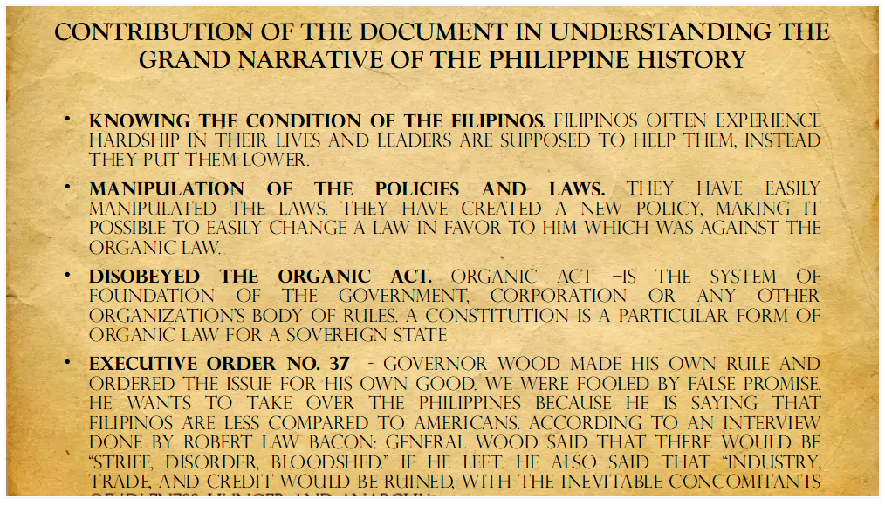

Relevance

